Jesmond Local Article –

During the festive season the staff at Pinetree would normally do a Secret Santa, as with many groups bringing humour and a pocket a joy to one another. This year however, the joy was amplified and spread a little further than the team themselves. Lavander Beauty based within Pinetree has worked with the charity; “Social Justice Lass” over the past 4 years. The charity themselves embody the true meaning of Christmas by aiding donations to children in lessprivileged backgrounds and less fortunate circumstances. This incredibly special cause helps the families of the North East show the love and joy that can sometimes be hindered by a price tag.

It's for this reason we were overjoyed with Lavander sharing a charity close to her heart with staff and members of Pinetree. With 12 families over all, the gifts were written on a small tag stating the age of 1 child and a gift of either pyjamas, slippers or a toy. These were hung on a small tree in the reception of the facility for staff and members to pick a tag and provide the proposed present.

We are in awe of the time taken by all to give a little back this Christmas as shown by the abundance of gifts below the tree. Even when all tags had been taken, the people wanted to help a little more and so brought more gifts to spread the joy further. The kind staff from Social Justice Lass are collecting all the gifts for the wrapping station, where they are then taken to those children in need.

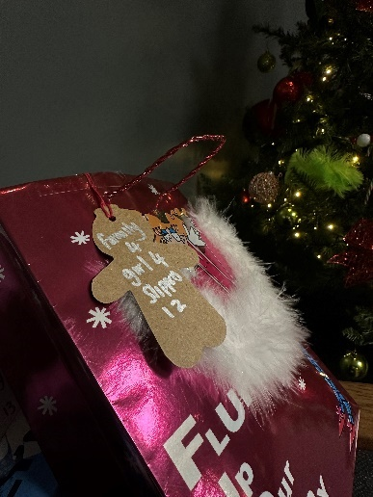This a wonderful charity Lavander and Pinetree are proud to be working with. We would like to wish a very Merry Christmas to all who have been involved and to the beautiful families Santa will be visiting this year.

